**SPECIAL ANGLES**

**FINDING THE EXACT VALUE OF A TRIGONOMETRIC RATIO**

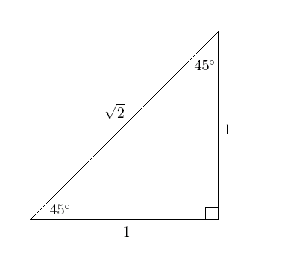

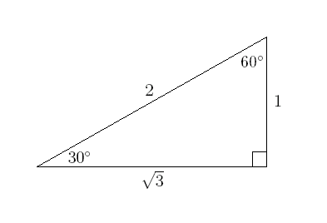

The above triangles, sometimes referred to as “special triangles” enable us to find the exact value of the trigonometric ratios for 30, 45, and 60 degree angles. This is useful when a calculator or table is not available or when it is important to have the EXACT value rather than a rounded off value for the trig ratio.

**45, 45, 90 TRIANGLE**

This is an isosceles triangle (two angles and two sides equal). If the side length of 1 is assigned to the equal sides, the hypotenuse can be calculated as .

Thus, the exact values are:

Sin 45o = cos 45o  (rationalized)

Tan 45o =  = 1

**30, 60, 90 TRIANGLE**

This triangle originates from an equilateral triangle with all sides equal to 2 units in length. Each angle is 60o. If you cut the equilateral triangle in half, you get triangle shown on the right above.

The exact values for the angles in this triangle are:

Sin 30o = Cos 60o = 

Sin 60o = cos 30o = 

Tan 30o =  Tan 60o = 